Project Design Phase-II
Solution Requirements (Functional & Non-functional)

Date | 6 July 2026
Team ID
Project Name | ShopEz E-Commerce Application
Maximum Marks | 4 Marks

Functional Requirements:
Following are the functional requirements of the proposed solution.
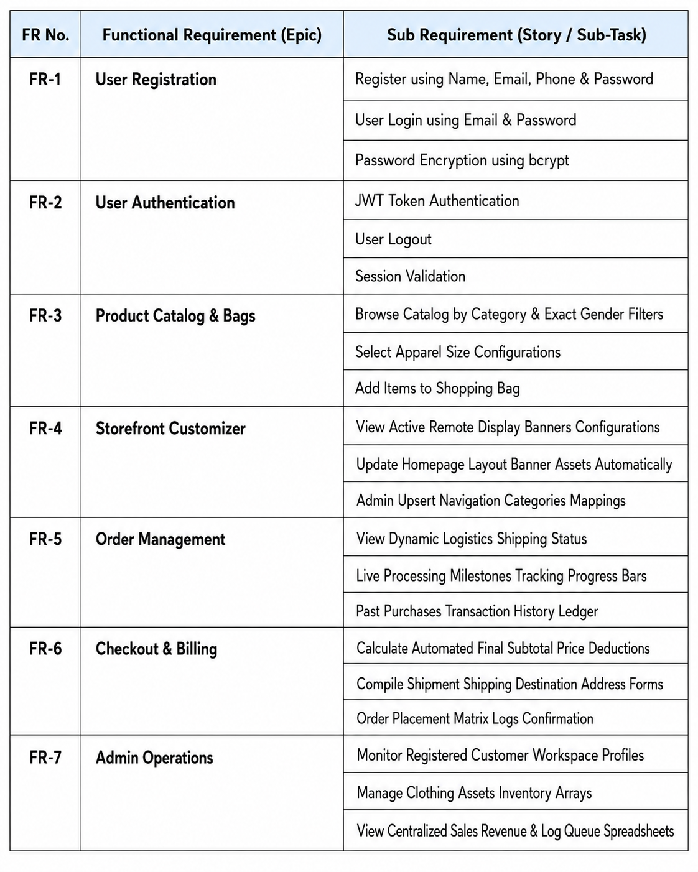
Non-functional Requirements:
Following are the non-functional requirements of the proposed solution.
NFR No. | Non-Functional Requirement | Description
NFR-1 | Usability | Simple, clean, and elegant interface for customers and store administrators.
NFR-2 | Security | Secure token-gated authentication using JWT and encrypted passwords via bcryptjs.
NFR-3 | Reliability | System should provide accurate item state management, search filters, and checkout computing.
NFR-4 | Performance | Predictive search lookups and dynamic database routing should execute within a few milliseconds.
NFR-5 | Availability | Application should run continuously with minimal system downtime.
NFR-6 | Scalability | Supports an increasing volume of active buyers, inventory item logs, and checkouts without impacting baseline latency.

